1. Login to <https://training.openspan.com/>
2. Click on Inventory

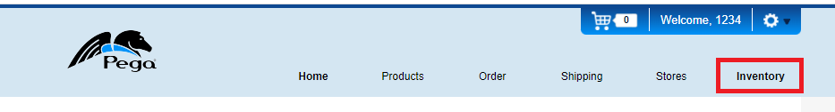

1. Extract all the data under Inventory into an excel sheet and name it “Inventory”

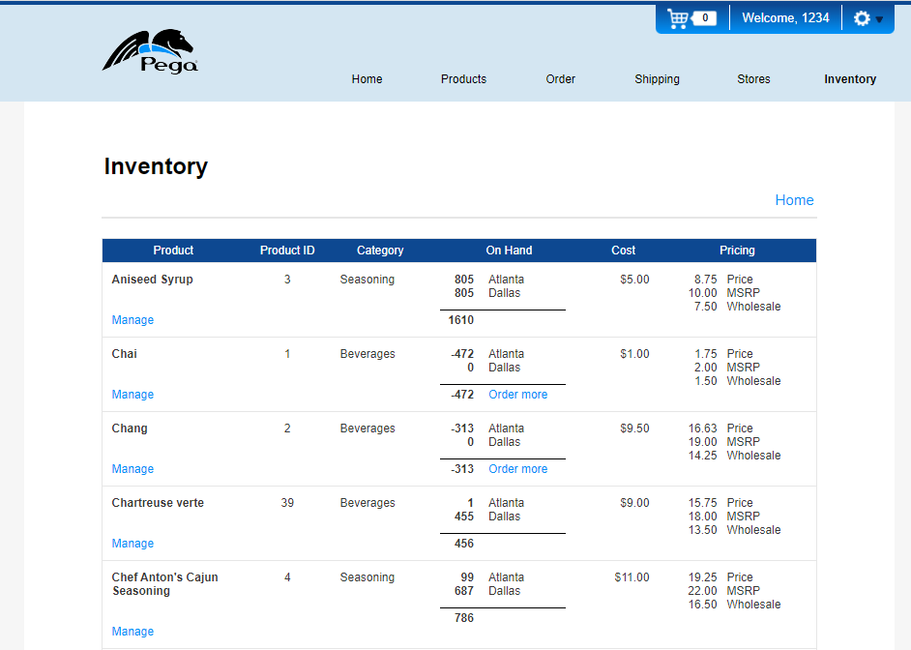

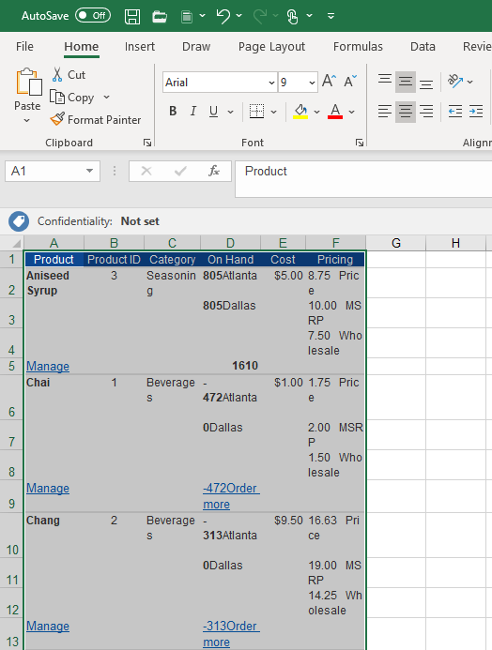

1. Go to Product > Beverages and extract all data to excel sheet and name in “Beverages”

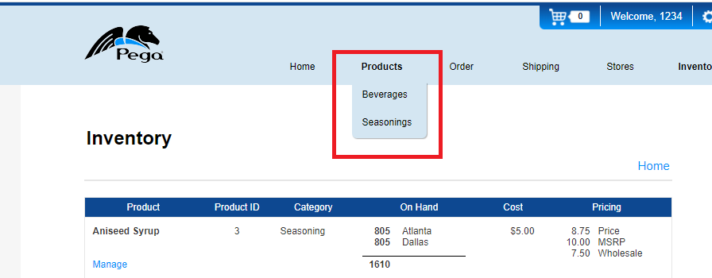

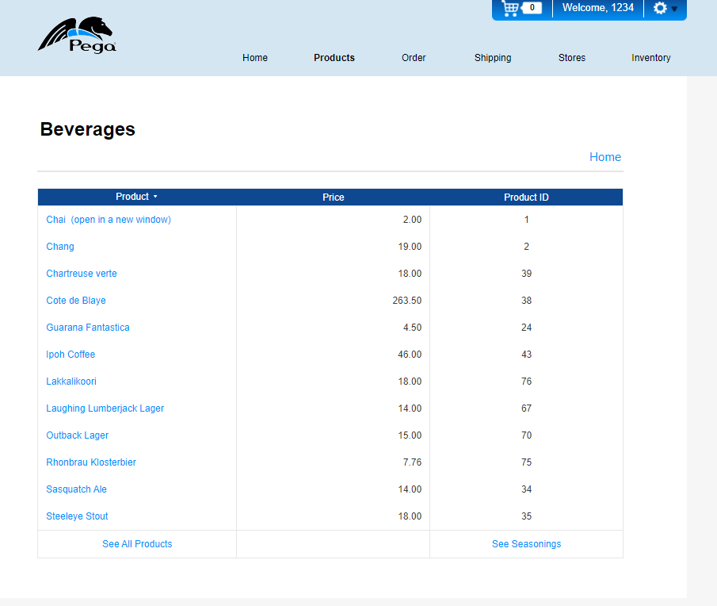

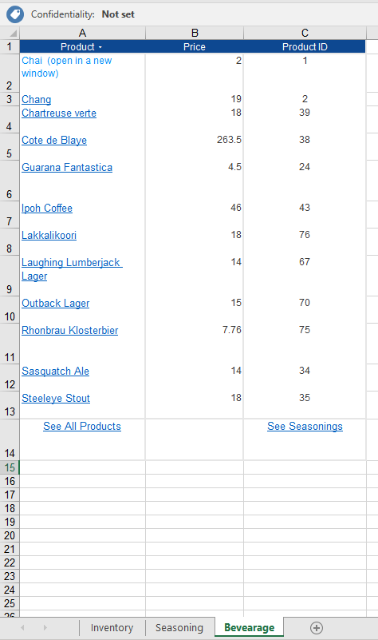

1. Go to Product > Seasoning and extract all data to excel sheet and name in “Seasoning”



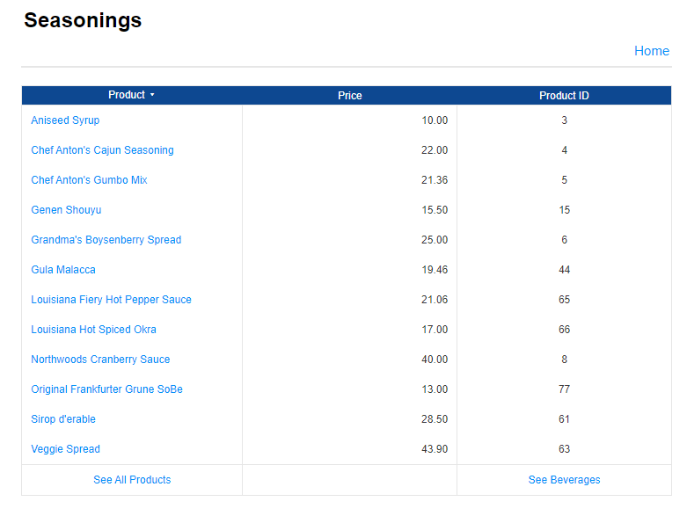

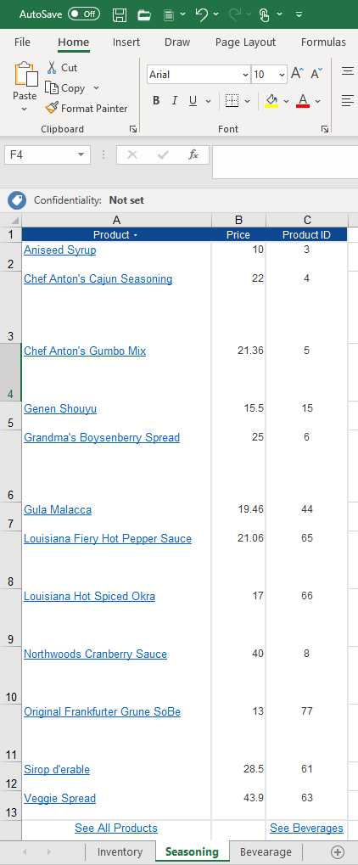

1. Go to Stores and extract all data to excel sheet and name in “Store”

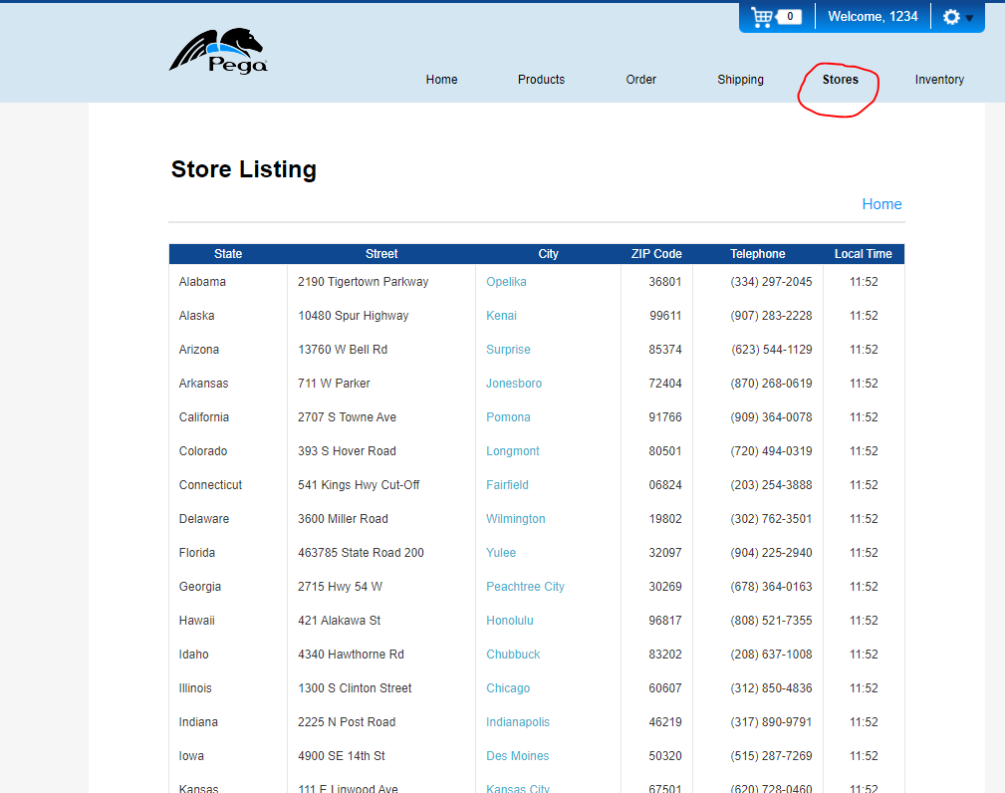

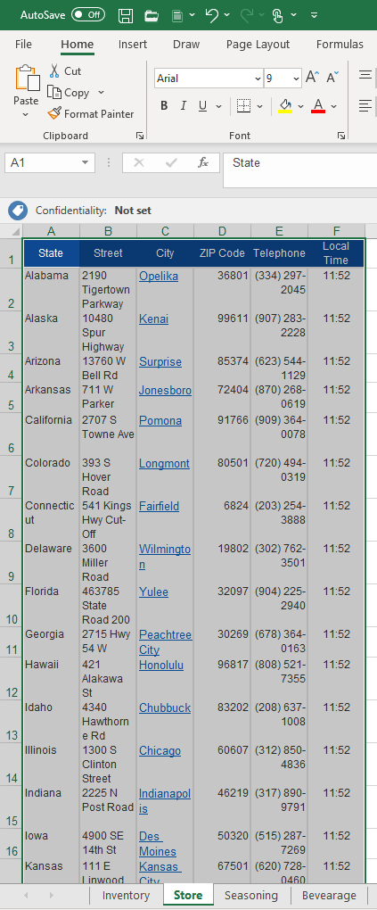

1. In excel sheet “Inventory” populate Column G using sheets “Beverage” and “Seasoning” by referring column C i.e. “Product ID”

**Note**: Product ID is common column both sheets “Beverages” and “Seasoning”

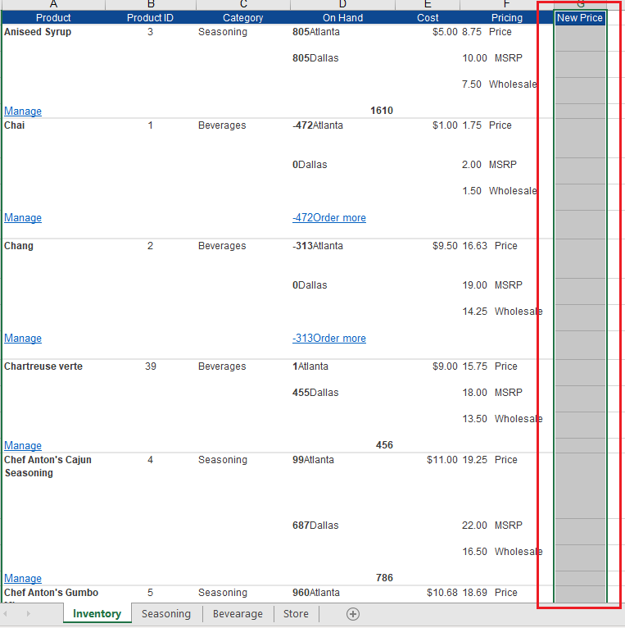

1. Populate column H using sheet “Store” by concatenating all address field where City is matching with City mentioned under column “On Hold” in sheet “Inventory”

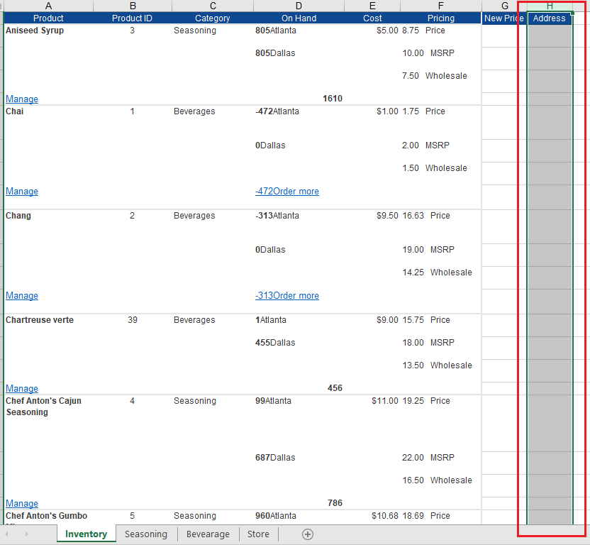

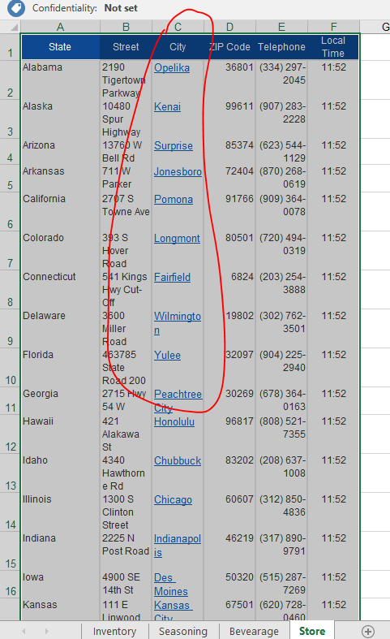

1. From sheet “Inventory” pick up top 3 inventories data as per “New Price” column and update the date into Word Template and save it

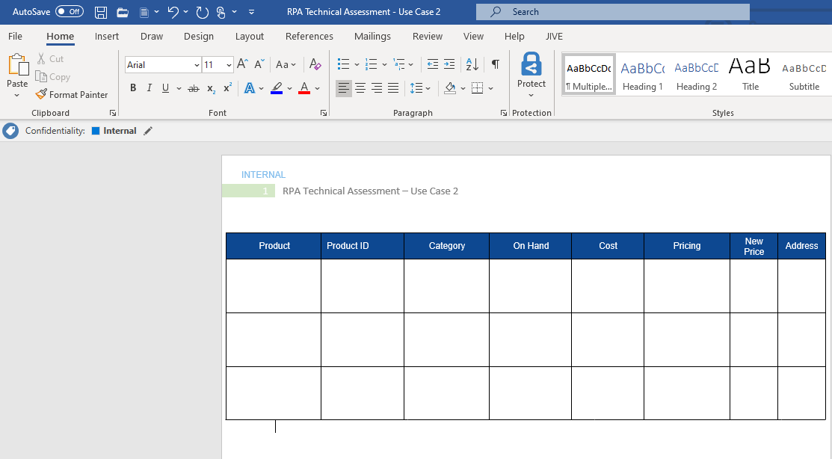

1. Once completed draft a mail and attach the word and excel document and share

